**CS5250 Advanced Operating Systems**

**Pop Quiz 1**

Name: ________________________________________

Student Number: _______________________________

1. Assuming integers are 4 bytes, show how memory is will be laid out for the following scenarios by filling in the content of memory (each box holds a byte):

int arr[2] = { 0x1e, 0xcafefeed};

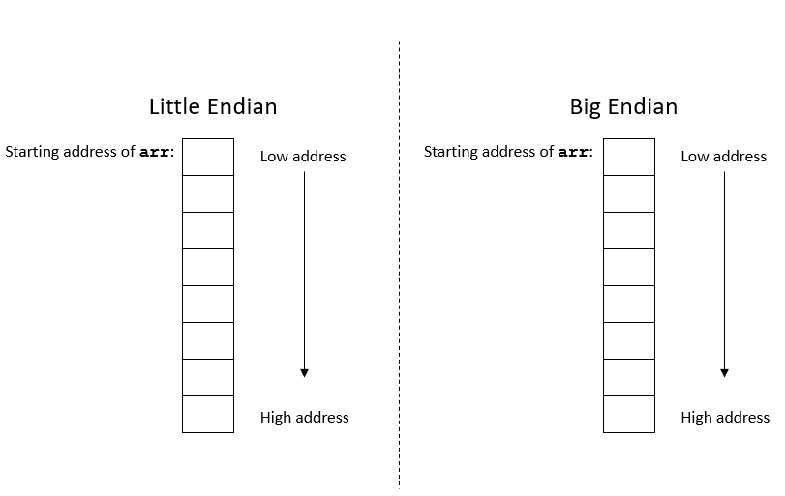

1. Suppose the CS register now contains the value “0xabc”, and the IP register contains the value “0x89”. What is the value of the program counter, i.e., CS:IP, in the x86 real-address mode?